_________’s
PERSONAL FITNESS PLAN
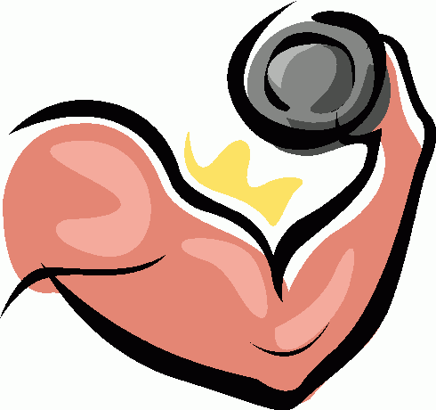

Name_________________________Period_____

Teacher___________________

MY PERSONAL FITNESS PLAN CONTRACT

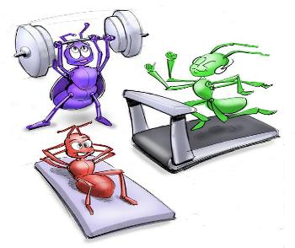
I, _____________________________, am going to make a commitment to helping build lifelong fitness and nutrition habits that will aid me in sustaining a long, healthy lifestyle. I will make an attempt to follow most, if not all, of the guidelines I have designed in my fitness plan. My fitness plan will identify areas where I need improvements in both fitness and nutrition. I will design realistic, achievable and measurable goals. My activities will be ones that I can consistently incorporate into my current lifestyle. I will do my very best to keep fitness logs so that I can actually see if I am achieving the guidelines of my fitness plan as well as seeing improvements in my overall fitness.

Benefits of a Fitness Plan
In this section, you are going to list 5 reasons why it is important for YOU to design and follow a fitness plan.

Fitness Plan Project
When you complete this project, you will accomplish the following:
- Setting specific short-term and long-term fitness goals
- Identify fitness activities that will help you accomplish your goals
- Determine how often, how hard and how long you will do the activities in a proposed calendar
- Track your progress
- Compare what you planned to what you accomplished and reflect on the process

Fitness Plan Questions
A. What are 2 things that you think you can do to make sure you stay motivated to execute your fitness plan?
1.
2.

B. What are 2 BIG obstacles that you think will stand in your way from consistently following your fitness plan?
1.
2.
I understand the conditions of my fitness plan and will do my best to incorporate this plan into my daily life.

_____________________________________________ __________
Student Signature Date

_____________________________________________ __________
Parent Signature Date
Sources:
http://tms.ecol.net/fitness/fundhome.htm
http://invertebrateolympics.com/resources/_wsb_350x294_inverts+working+out++shrunk.jpg

As a Health and Physical Education Teacher and Lifelong Fitness advocate, my ultimate goal is to help as many people as I can reach a state of Health and Wellness. Rather than giving you a fitness plan to follow and “making” you complete certain activities, I have created this Personalized Fitness Plan to serve as a guide for individuals to learn and understand the concepts behind creating a Fitness Plan and Routine. The Fitness Plan can be formed around any personal interests or activities. Whether you prefer to work out in a Fitness Facility, be outdoors, participate in activities at-home, or on the TV/DVD’s, this plan can be applied.
While learning the following information, the individuals completing this plan can become competent with creating a program that works for them. It can be geared toward any lifestyle, fitness level, goal attainment, and situation. This is a wonderful tool to use as an ongoing way to obtain and maintain a state of health and fitness.
Your goal may not be weight loss and that is ok! It is not about being "skinny". My goal is to help you become HEALTHY, toned, and overall HAPPY and CONFIDENT. I hope to lead you toward a LIFESTYLE full of health and wellness. I have met an abundance of people over the years that have been positively impacted by fitness programs, mentally and physically, and only want to help more people achieve that for themselves.

This Fitness Plan can be applied to anyone and everyone. Like mentioned previously, it is a versatile way to form a program around what interests you. Whether you are someone that has never worked out a day in your life, or are someone who is already in a good state of fitness but needs new habits or ideas, this plan can help you!

I wholeheartedly hope that you find value in this Personalized Fitness Plan and commend you on taking a step toward a better YOU!

Stay Healthy,
Mrs. Sill

“Two months from now, you will thank yourself…”

“The fact that you aren’t where
you want to be should be enough motivation!”

“Strength doesn’t come from what you can do. It comes from overcoming the things you once thought you couldn’t!”

“It takes 4 WEEKS for you to notice a change, 8 WEEKS for your friends to notice a change, 12 WEEKS for the rest of the world to notice a change… but it takes ONE DAY to decide that you are WORTH THE CHANGE…”

DISCLAIMER
It is strongly recommended that you consult with your physician before beginning any exercise program.
You should be in good physical condition and be able to participate in the exercise.
This Personalized Fitness Plan is not designed by a licensed medical care provider and represents that it has no expertise in diagnosing, examining, or treating medical conditions of any kind, or in determining the effect of any specific exercise on a medical condition.
You should understand that when participating in any exercise or exercise program, there is the possibility of physical injury. If you engage in this exercise or exercise program, you agree that you do so at your own risk, are voluntarily participating in these activities, assume all risk of injury to yourself, and agree to release and discharge this Personalized Fitness Plan from any and all claims or causes of action, known or unknown, arising out of negligence.

COPYRIGHT

This Personalized Fitness Plan is protected by copyright laws and is the copyright of Tara Sill. The document may not be copied, reproduced, republished, uploaded, posted, broadcast or transmitted in any way. All intellectual property rights in relation to this Fitness Plan are reserved and owned by Tara Sill. Modification of any of the materials or use of the materials for any other purpose will be a violation of copyright laws and other intellectual property rights.

PERSONALIZED FITNESS PLAN
TABLE OF CONTENTS
PART 1: FITNESS TESTING/ASSESSMENTS
PART 2: PERSONAL FITNESS GOALS
PART 3: PERSONAL FITNESS PLAN/CALENDAR

Fitness Plan Glossary of Terms:

- 5 Fitness Components: Muscular Strength (MS); Muscular Endurance (ME); Cardiovascular (CV); Flexibility; and Body Composition (BC)
- Muscular Strength: body’s ability to exert force for a very short period of time using a lot of energy, usually 1 or 2 reps.
- Muscular Endurance: ability of a muscle or group of muscles to sustain repeated contractions over a period of time
- Cardiovascular: body’s ability, over a sustained period of time, to deliver oxygen and nutrients to working muscles as well as remove waste (Carbon Dioxide) from the body.
- Flexibility: ability to move joints and use muscles through their full range of motion.
- Body Composition: ratio of lean body mass to fat in the body. Lean mass and Fat mass make up body weight.
- FITT Formula: Frequency; Intensity; Time and Type
- Frequency: how often you do an activity
- Intensity: how hard you do an activity. Usually measured by using Heart Rate Zone or RPE scale for cardiovascular activities and weight and speed for muscular strength/endurance activities.
- Time: how long you do an activity. Can be measured in either time (hours/mins/secs.) or sets/reps.
- Type: type of activity that you choose to perform to meet a specific goal (also known as specificity)
- Principles of Exercise: The terms specificity, progression, overload, warm-up and cool-down. In other words, explaining how to progress (progression), overload, warm-up, and cool-down an activity in order to gain fitness benefits from exercise.
- Specificity: choosing the right type of activities that specifically match your activity goal. For example, if you want to improve how many push-ups you do, you need to build the muscles in your arms and chest, not legs.
- Progression: increase the frequency, intensity and/or duration over periods of time in order to improve. In other words, how are you going to change the way you do your activities from Week 1 to Week 2 in order to make them more challenging.
- Overload: work hard enough and long enough at intensity levels that overload your body, above resting conditions to bring about improvement. For example, if you can lift 10lb. weights pretty easily for a long time, then you probably should lift a weight that causes you to struggle slightly.
- Warm-up: the process before your main workout begins in order to “heat up” your muscles. Usually involves a low intensity, steady activity to get blood flowing and stretching. Total warm-up time should be 5-10 minutes.
- Recovery: Recovery is as important as the workouts themselves. Your muscles need to recuperate and have time to grow back stronger. For cardiovascular workouts consider a resting period of 24 hours between workouts. For muscular strength and endurance activities consider 24-48 hours rest per large muscle group that was focused on. For flexibility exercises, consider 24 hours or less of rest between workouts.
- Rest between sets (MS/ME) – If your goal is to increase your strength you should be doing 1-8 reps of a heavier weight (relative to student), and resting up to 2 minutes between sets. If your goal is growth you should be doing 8-15 reps per set with a moderate weight (relative), and resting about 1 minute between sets. If your goal is endurance (tone), then you should be doing a lightweight workout (relative) consisting of 15 reps or more, and resting for less than 60 seconds between sets.

WHEN USING WEIGHTS AS PART OF AN EXERCISE PROGRAM, REMEMBER THAT ALIGNMENT OF THE SPINE & JOINTS ALONG WITH PROPER BREATHING, USING FULL RANGE OF MOTION, AVOIDING EXTRA MOVEMENTS AND CHOOSING THE APPROPRIATE EXERCISES AND WEIGHT CAN HELP LEAD TO A SUCCESSFUL WORKOUT!

FITNESS PLAN BRAINSTORMING SHEET

By filling out this worksheet, you will be able to start thinking about what you might want to adopt in your Fitness Plan. This worksheet is intended to help you visualize your strengths and weaknesses, good and bad habits, motivation strategies, activities that you enjoy as well as general warm-up and cool-down exercises. When designing your Fitness Plan, you will end up using the information on this worksheet as the substance.

My 2 fitness strengths are: 1. ___________________ & 2. ___________________

My 2 fitness weaknesses are: 1. ___________________ & 2. ___________________

Strategies To Stay Motivated
1.____________________________
2.____________________________
3.____________________________
Challenges/Obstacles To Staying With Plan
1.____________________________
2.____________________________
3.____________________________

WARM-UP ACTIVITIES/EXERCISES THAT I ENJOY
1. ______________________________
2. ______________________________
3. _____________________________
Flexibility/Stretching Exercises That I Enjoy
1.____________________________
2.____________________________
3.____________________________

Muscular Endurance/Strength Exercises That I Enjoy
1.____________________________
2.____________________________
3.____________________________
Cardiovascular Exercises That I Enjoy
1.____________________________
2.____________________________
3.____________________________

COOL-DOWN ACTIVITIES THAT I ENJOY
1. ______________________________
2. ______________________________
3. _____________________________

GOAL SETTING SHEET
Questions that will help you toward setting goals

1. Where do you perform most of your fitness activities?
Home Outside Fitness Facility (gym, health club, pool, etc.)
Explain why?

2. What time of day can you do most of your exercise?
Any time Morning Afternoon Evening

3. What equipment do you have available on a regular basis? (circle all that apply)
Nothing Free Weights (dumbbells, etc.) Weight machines Treadmill or other cardio home machines
Resistance balls or other core home equipment Resistance Bands Exercise Videos Jump Ropes
Bicycle, Skateboards, Roller Blades, other (explain) ________________________________________________________________

4. Which of the following are your personal obstacles in adopting a regular fitness program?
- Intimidated and embarrassed when I exercise e) I get bored pretty easily when I exercise
- I can’t really find the time to exercise f) I have to exercise alone
- I get frustrated because I don’t see results right away g) My exercise setting does not meet my needs
- Family obligations h) I do not have personal obstacles, I am lazy
5. If you wanted to find out more about how to live a healthier lifestyle, what two types of people do you think you could talk to?
a) b)

6. What sports or fitness activities do you enjoy participating in and why?
7. What type of fitness activities/sports do your parents/guardians participate in?
8. Which one of the Fitness Components do you need to improve the most? Why?

9. Which one of the Fitness Components do you feel is your strongest? Why?
Setting Goals
Setting goals involve following certain criteria:
1. Be specific: What is it exactly that you would like to accomplish?
2. Be realistic: Do not make goals that are unachievable
3. Be flexible: If you say you’ll work out 3 days a week, or for 30 minutes, and something comes up, you can make it up another day, or add some extra time elsewhere in the workout.
4. Measurable: If you are not able to measure your workout, you are unable to measure your progress
5. Recognize Obstacles: What is standing in your way of achieving your goals?
6. Have short and long-term goals: Stepping stones will let you know if your program is working.
7. Write them down: Write down your goals, post them in places where your support system can see.

What are your fitness goals? (circle all that apply)
Appearance Cardiovascular endurance Reduce body fat Get more flexible
General Health Muscular definition Muscle size Muscle strength
Self-esteem or confidence Speed Sports Performance Reduce my stress level
Tone and shape my body Lose weight Improve posture Medical reasons

Example of writing a good cardiovascular goal: I would like to lower my mile time from 8:30 to 8:00 by June.
Example of writing a bad cardiovascular goal: I would like to run faster.
Example of writing a good muscular strength goal: I would like to increase my pull-up score from 3 to 5 by June.
Example of writing a bad muscular strength goal: I would like to get stronger.

Write an example CV goal here:_________________________________________________________
Write an example MS/ME goal here:_____________________________________________________
Write an example Flexibility goal here:____________________________________________________

PART 1: FITNESS TESTING/ASSESSMENTS
Fitness Testing allows you to know what your current state of Fitness is for each of the 5 areas of Health-Related fitness that act interchangeably toward your overall wellness. Those areas include Cardiovascular Endurance, Muscular Endurance, Muscular Strength, Flexibility, and Body Composition. The given assessments allow you to create a benchmark for each of your areas of fitness, as well as obtain specific data throughout your fitness journey to monitor its effectiveness and success. You will re-do the Fitness Assessments throughout the two-month period to compare your results and hopefully improve toward your end goal.
*Please make sure to COMPLETE THE ASSESSMENTS IN THE ORDER THEY ARE LISTED ON THE WORKSHEET PROVIDED to allow proper warm-up and cool down periods. You may do an additional warm-up activity, if you prefer, or gradually increase your speed during the 1 Mile Walk/Jog.

THE FITNESS ASSESSMENTS:
1. Resting Heart Rate
2. 1 Mile Walk/Jog
3. Exercise Heart Rate
4. Push-Up Test
5. Sit and Reach
6. Body Measurements

*MAKE SURE YOU READ THE TEST EXPLANATIONS AND GUIDELINES TO ENSURE THAT YOU ARE COMPLETING THEM CORRECTLY AND SAFELY!

FITNESS TESTING DATA/PROGRESS CHART

 | DATE  DAY 1: __________ | DATE  WEEK 4:_________ | DATE  WEEK 7: _________ | DATE  WEEK 10: ________
RESTING  HEART RATE | ________ BPM | ________ BPM | ________ BPM | ________ BPM
1-MILE  WALK/JOG | Minutes: Seconds  _____________ | Minutes: Seconds  _____________ | Minutes: Seconds  ______________ | Minutes: Seconds  ______________
EXERCISE HEART RATE | _____________ BPM | _____________ BPM | _____________ BPM | _____________ BPM
MUSCULAR STRENGTH AND ENDURANCE  Push-Up Test | Push-ups:______ | Push-ups:______ | Push-ups:______ | Push-ups:______
FLEXIBILITY  Sit-and-Reach | Centimeters:____ | Centimeters:____ | Centimeters:____ | Centimeters:____
BODY COMPOSITION  Measurements  **See chart for description of exact body locations! | Chest: _________  Right Arm:_________  Left Arm:_________  Stomach:_______  Hips:_________  Right Leg:________  Left Leg: _________  Weight: _________ | Chest: _________  Right Arm:_________  Left Arm:_________  Stomach:______  Hips:_________  Right Leg:_________  Left Leg: _________  Weight: __________ | Chest: _________  Right Arm:_________  Left Arm:_________  Stomach:_______  Hips:_________  Right Leg:_________  Left Leg: _________  Weight: __________ | Chest: _________  Right Arm:_________  Left Arm:_________  Stomach:_______  Hips:_________  Right Leg:_________  Left Leg: _________  Weight: __________

TEST EXPLANATIONS AND GUIDELINES

1) RESTING HEART RATE:
Use the tips of your first two fingers (not your thumb) to press lightly over the blood vessels on your wrist or neck. Count your pulse for 15 seconds (use a stopwatch to track the time) and multiply by 4 to find your one-minute’s worth of a Resting Heart Rate.
**If you are having difficulty locating your pulse, put your fingers on the bone located on the inside of your wrist, then move them a finger tip’s length/centimeter toward the midline of your wrist. This should help you find it. Another option is to use your Carotid Pulse, which is located on your neck underneath the point where the side and bottom of your jawbone meet.
**The healthy average Resting Heart Rate is anywhere between 60-80 beats per minute.
The American Heart Association states that, “Even if you’re not an athlete, knowledge about your heart rate can help you monitor your fitness level — and it might even help you spot developing health problems.
Your heart rate, or pulse, is the number of times your heart beats per minute. Normal heart rate varies from person to person. Knowing yours can be an important heart-health gauge.”
RADIAL PULSE CAROTID PULSE
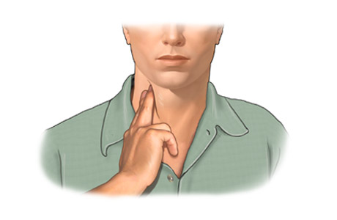
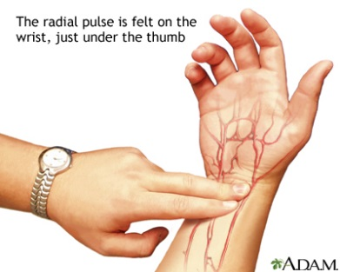

2) 1-MILE WALK/JOG:
This test can be completed inside or outside, on a treadmill, track, or on a road/sidewalk. The main thing to remember is to consistently travel the same pattern or area when completing future walk/jogs to assess progress and fitness gains.
If you choose to do the test outside, you can utilize a technological device like a smartphone, Fitbit, or pedometer to track your distance. As you complete the Walk/Jog, your main goal is to achieve your best possible time for the distance of one mile. If that means you have to walk the entire distance and that is your personal best, that is fine. If it means that you can jog or even run the mile, that is fine. This is a benchmark to see what you can be achieved and how you can take your fitness further by decreasing your time in future assessments.
When you are finished with the 1-Mile Walk/Jog, record how long (MINUTES AND SECONDS) it took you to complete it. Then move quickly onto recording your Exercise Heart Rate (the next fitness assessment).
**Remember to always stay hydrated. Drink plenty of water before, during, and after all activity.

3) EXERCISE HEART RATE:
IMMEDIATELY after completing the 1-Mile Walk/Jog, record your Exercise Heart Rate. Use the tips of your first two fingers (not your thumb) to press lightly over the blood vessels on your wrist or neck. Count your pulse for 15 seconds (use a stopwatch to track the time) and multiply by 4 to find your one-minute’s worth of an Exercise Heart Rate.
**If you are having difficulty locating your pulse, put your fingers on the bone located on the inside of your wrist, then move them a finger tip’s length/centimeter toward the midline of your wrist. This should help you find it. Another option is to use your Carotid Pulse, which is located on your neck underneath the point where the side and bottom of your jawbone meet.
**See the Exercise Heart Rate Chart for age-specific recommendations of a healthy zone.

RADIAL PULSE CAROTID PULSE

4) PUSH-UP TEST:
Women: Females can choose to do a modified push-up or a full body (standard) push up. Modified push-ups start with knees bent and touching the floor. Starting in the up position, hands should be slightly ahead of the shoulders so hands are in the proper position for the downward motion.
Men: Start in the standard push-up position (elevated). Hands should be shoulder-width apart, arms extended straight out under the shoulders, back and legs in a straight line, and toes curled under.
-Lower until the chest is about 2 inches from the floor and rise up again.
-Perform the test until you cannot complete any more push-ups while keeping your back straight and, if you are a male, keeping the legs straight as well. The key to completing the test properly is to maintain a rigid position and keep the back flat. If necessary, you can take a brief rest in the up position (not lying on the floor).
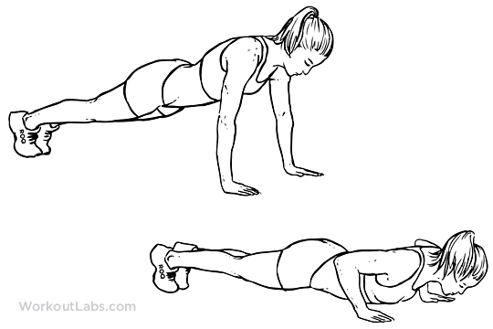
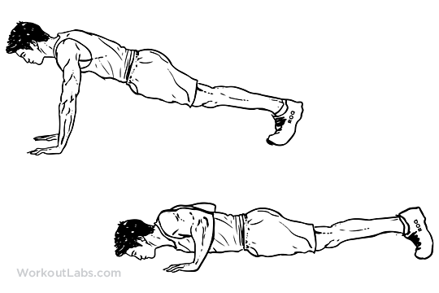
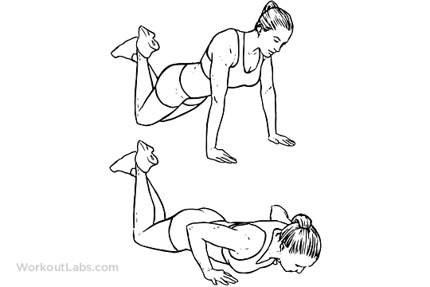
Regular Push-Ups Modified Push-Ups

5) SIT-AND-REACH TEST:
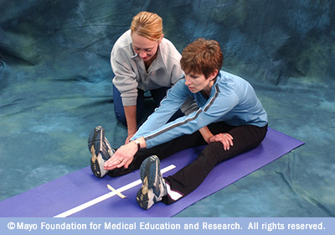
The sit and reach test is a common measure of flexibility, and specifically measures the flexibility of the lower back and hamstring muscles. This test is important as because tightness in this area is implicated in lumbar lordosis, forward pelvic tilt and lower back pain. This test was first described by Wells and Dillon (1952) and is now widely used as a general test of flexibility.

SIT AND REACH TEST
0/tape line/where your heels should be

TO COMPLETE THE TEST:
- Sit on the floor with the yardstick between your legs, your feet 10 to 12 inches apart, and your heels even with the tape at the Tape Line (at the 0 mark of the ruler).
- Place one hand over the other...
- Slowly stretch forward without bouncing or jerking and slide your fingertips along the yardstick as far as possible.
- Complete the test three times.
- Record your best score in centimeters.
*Standard Fitnessgram sit-and-reach assessments are recorded in inches, but using centimeters will give you a more exact number of progression with your Flexibility.

*If you have completed the
fitness tests in order, you will be
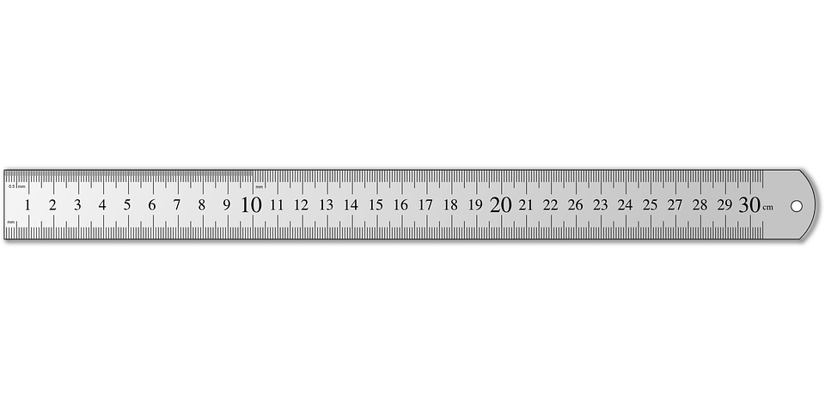
well warmed-up by the time you
are up to the sit and reach test.

**Tape the ruler paper to the ground
right before the “ruler” begins.

6) BODY MEASUREMENTS:
The body parts you should always measure and how to measure them properly:
- Neck – Measure around the smallest part of your neck.
- Chest– Measure around the fullest part of your bust, under your armpits and around your shoulder blades.
- Arms – Measure around the largest part of your arms (flexed or not flexed, just make sure to do it the same every week.)
- Waist – Measure around the smallest part of your waist, if you don’t have a pronounced waistline and you’re fairly straight, measure at the belly button.
- Hips – Measure around the widest portion of your hips.
- Thighs – Measure the circumference of the fullest part of your thigh, usually about three inches from your crotch.
- Weight- Weigh yourself on a scale in lbs.
*Muscle weighs the same as fat but does not take up as much space(muscle tissue is more dense than fat tissue), which means you could lose a ton of fat and not lose much weight if you’ve been putting on lean muscle mass. What commonly happens when people begin a new fitness program is they lose fat and replace it with muscle. This means the scale could remain the same even though you’ve lost five pounds of fat and replaced it with five pounds of muscle. A good thing to always remember is this: losing inches is a great tracker of success!
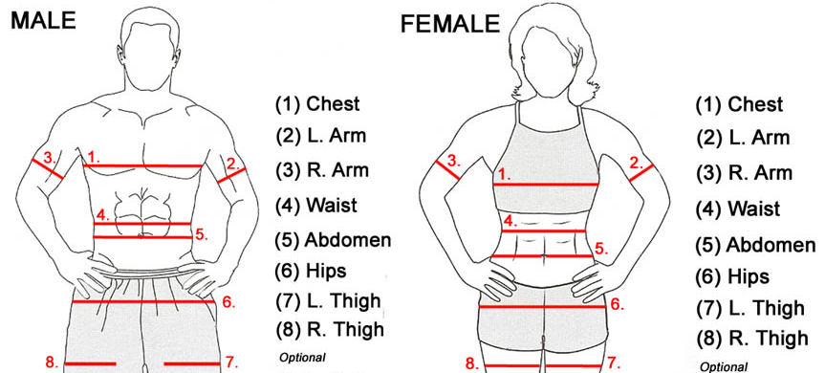
BMI MEASUREMENT CHARTS:

HEALTHY RECOMMENDATIONS
The following information is a collection of Healthy Fitness Recommendations based on the given Fitness Tests you have completed. This is not necessarily where you may be when you begin your Fitness Plan Program, so do not let it discourage you if your numbers do not fall into the Healthy Zone, but will give you a good idea of what you should around. The Fitnessgram data provided includes more assessments than the ones we have completed. There are a number of assessments that focus on the different areas of Health-Related Fitness. The ones completed for this Fitness Plan are the foundational ones that give you an overall idea of your current state of fitness. Additionally, Healthy Heart Rate Charts are provided below:

HEALTHY RESTING HEART RATE CHART
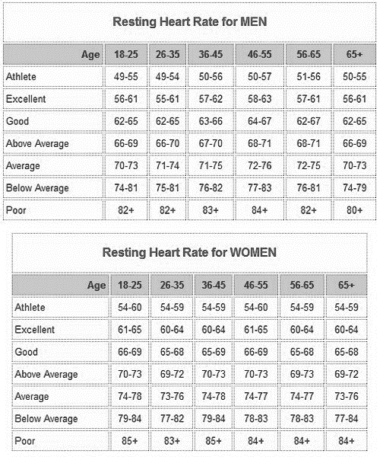

HEALTHY EXERCISE HEART RATE CHART
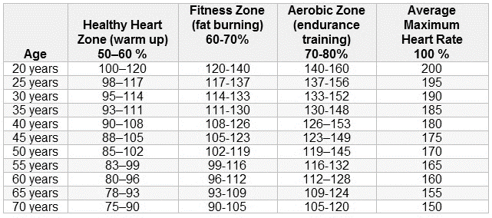

While creating your Fitness Plan Calendar in Part 3, keep the following Chart in mind. The following information breaks down the different sections of your Exercise Heart Rate Zone and shows what benefits arise most from each given area. Use this to help you progress through your workout routine. Always make sure to track your heartrate during any and all activities to assure that you are SAFE and effectively working toward your given goals.
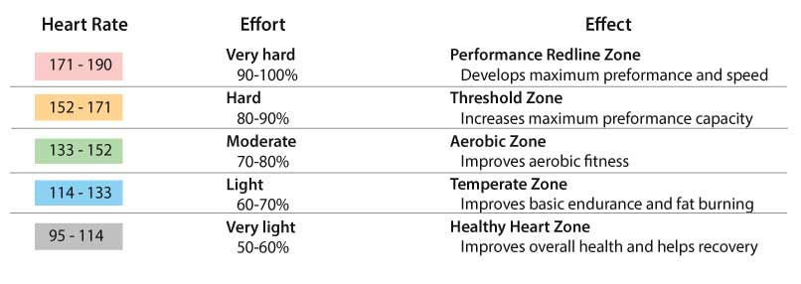
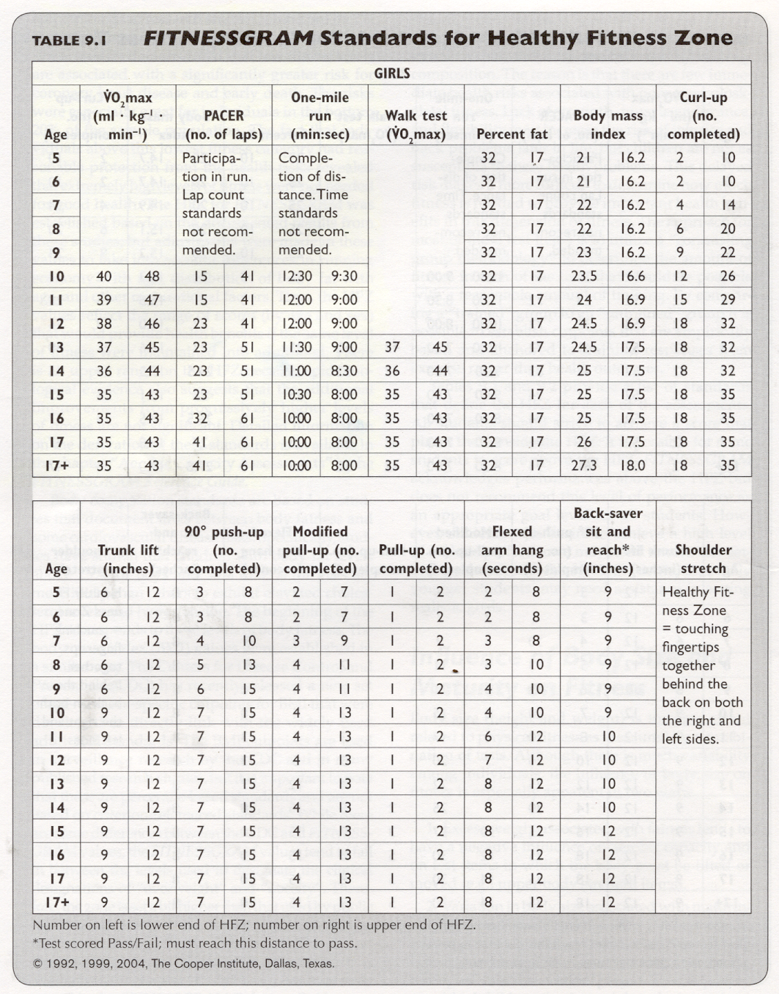
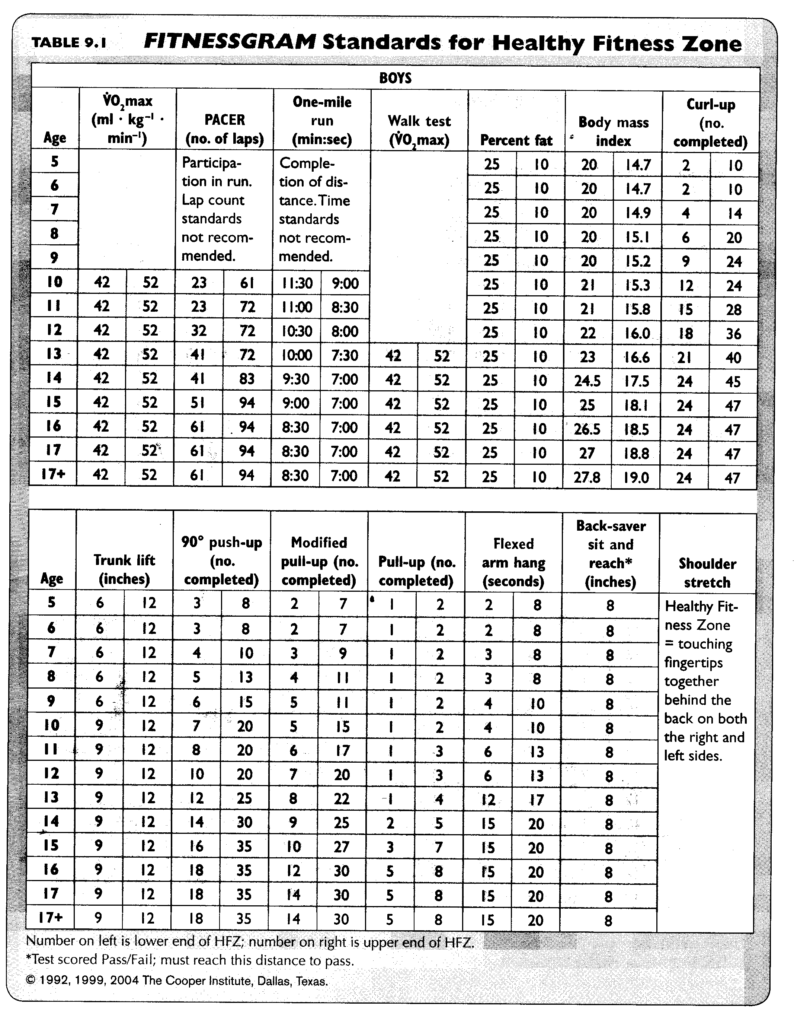
PART 2: PERSONAL FITNESS GOALS
Each Fitness test you completed focuses on one of the 5 given areas of Health-Related Fitness to give you a holistic idea of your current state of fitness. With your test results in mind, use the given Goals Worksheet to create SPECIFIC and MEASURABLE goals for each category that reflect on the given fitness test results. Ask yourself, “What are my goals (# of push-ups, weight, time for the mile run, and etcetera)?”
Cardiovascular Endurance
The ability to exercise the entire body for long periods of time. It requires a strong heart, healthy lungs, and clear blood vessels to supply the body with oxygen. Activities to improve fitness in this area include running, swimming and aerobic dance. A person should do the activity continuously for a minimum of 20 minutes within their target heart rate zone. Endurance/cardiovascular activity should be done a minimum of 3 days per week. Every other day is preferable. The mile or the pacer will measure fitness testing in this area.
Muscular Strength
The amount of force you can exert with your muscles. It is often measured by how much weight you can lift. People with strength have fewer problems with backaches and can carry out their daily tasks efficiently. Examples of muscular strength include: push-ups, lifting heavy weights with few repetitions, and pull-ups. Fitness testing is measured by doing push-ups.
Muscular Endurance
The ability to use the muscles, which are attached to the bones, many times without getting tired. People with good muscular endurance are likely to have better posture, have fewer back problems, and resist fatigue better than people who lack muscular endurance. You can improve muscular endurance by lifting weights with many repetitions or doing sit-ups. Measuring the number of sit-ups done correctly is used for fitness testing.
Flexibility
The ability to use your joints fully. You are flexible when the muscles are long enough and the joints are free enough to allow movement. People with good flexibility have fewer sore and injured muscles. Stretching before and after activities will help to improve flexibility. The sit-and-reach and the trunk lift are two tests used to measure flexibility.
Body Composition
The percentage (ratio) of body weight that is fat in comparison to other body tissue, such as bone and muscle. People who have a high percentage of fat are more likely to be ill and have a higher death rate than lean people. Exercise and eating the right foods in the proper amounts can improve body composition. Body composition can be measured using an instrument called calipers, a specialized scale, or by calculating the body mass index (BMI) which uses height and weight to determine your BMI.
FITNESS TESTING GOALS
What state of Fitness do you want to have? What are you working toward?
RESTING  HEART RATE | ________ BPM
1-MILE  WALK/JOG | Minutes: Seconds  ________________
EXERCISE HEART RATE | _____________ BPM
MUSCULAR STRENGTH AND ENDURANCE  Push-Up Test | Push-ups:______
FLEXIBILITY  Sit-and-Reach | Centimeters:______
BODY COMPOSITION  Measurements  **See chart for description of exact body locations! | Chest: _________  Right Arm:_________  Left Arm:_________  Stomach:_________  Hips:_________  Right Leg:_________  Left Leg: _________  Weight: __________

THE FITT PRINCIPLE
Overload and progression are two basic training principles. Overload refers to the amount of load or resistance on the body than it is normally accustomed to in order to increase fitness. Progression is the way in which an individual should increase the load. It is a gradual increase either in frequency, intensity, or time or a combination of all three components. The FITT Principle describes how to safely apply the principles of overload and progression:
FREQUENCY is how often a person performs the targeted health-related physical activity. For each component of health-related fitness, a safe frequency is three to five times a week.
INTENSITY is how hard a person exercises during a physical activity period. Intensity can be measured in different ways, depending on the related health-related component. For example, monitoring heart rate is one way to gauge intensity during aerobic endurance activities, but gives no indication of intensity during flexibility activities
TIME is the duration of physical activity. As with the other aspects of the FITT principle, time varies depending on the health-related fitness component targeted. For example, flexibility or stretching may take 10-30 seconds for each stretch, while the minimum time for performing aerobic activity is 20 minutes of continuous activity.
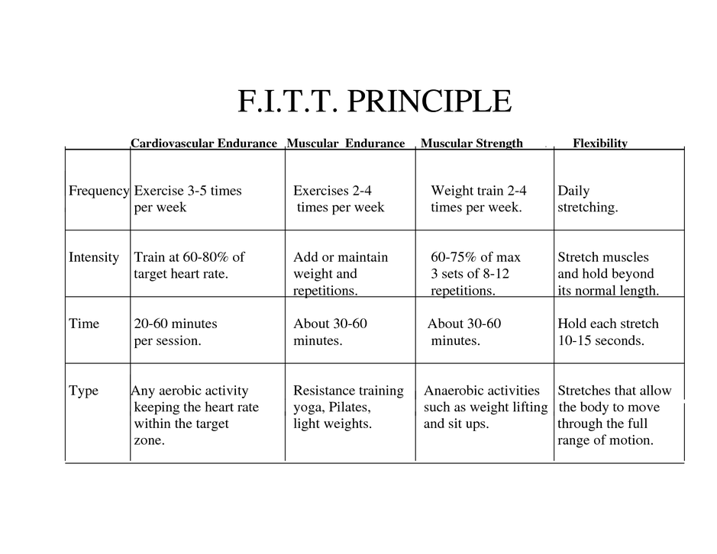
TYPE or specificity, refers to the specific physical activity chosen to improve a component of health-related fitness. For example, an individual working to increase arm strength must exercise the triceps and biceps, while an individual working to increase aerobic endurance needs to jog, run, swim or perform some other aerobically challenging activity.

CARDIOVASCULAR
ACTIVITY EXPANSION-Applying the FITT PRINCIPLES

Choose ONE activity from the Cardiovascular category on your Fitness Plan Brainstorming Sheet. You need to explain how you will specifically warm-up, cool-down, progress from week 1 to week 2, and what obstacles might be in your way for each of the activities. Use the cardio example below to help you.
CARDIOVASCULAR SHORT TERM GOAL: ______________________________________

CARDIOVASCULAR LONG TERM GOAL: _______________________________________

CARDIO ACTIVITY: ____________
WARM-UP: (How are you preparing your body for this workout?)
The exercise(s) that I’m doing to warm-up is:

The specific muscle(s) that I will target during this workout are:

Week 1 F.I.T.
Frequency = ____days/week How often (days/week) are you going to do this activity?
Intensity = ____-____BPM How hard? What HR range will your workout be in?
Time = ____min How long? What is the total time of your workout including warm-up & cool-down?

**PROGRESSION- WEEK 2 NEEDS TO BE MORE CHALLENGING THAN WEEK 1 BY ADJUSTING ANY COMBINATION OF THE FREQUENCY, INTENSITY OR TIME.

Week 2 F.I.T.
Frequency = ____days/week How often (days/week) are you going to do this activity?
Intensity = ____-____BPM How hard? What HR range will your workout be in?
Time = ____min How long? What is the total time of your workout including warm-up & cool-down?
COOL-DOWN: (how are you preparing your body to recover from this workout?)

OBSTACLES: (what two variables are hindering you from completing your F.I.T. goals?)

MUSCULAR STRENGTH/ENDURANCE
ACTIVITY EXPANSION-Applying the FITT PRINCIPLES

Choose ONE activity from the Muscular Strength/Endurance category on your Fitness Plan Brainstorming Sheet. You need to explain how you will specifically warm-up, cool-down, progress from week 1 to week 2, and what obstacles might be in your way for each of the activities. Use the cardio example below to help you.

MS/ME SHORT TERM GOAL:_________________________________________________

MS/ME LONG TERM GOAL: _________________________________________________

MS/ME ACTIVITY #1: ______________________________________________________
WARM-UP: (How are you preparing your body for this workout?)
The exercise(s) that I’m doing to warm-up is:

The specific muscle(s) that I will target during this workout are:

Week 1 F.I.T.
Frequency = ____days/week How often (days/week) are you going to do this activity?
Intensity = _____RPE How hard? What is the RPE (1-10 Scale) for this exercise?
Sets = ____ Repetitions: ____ Weight:_________
Time = ____min How long? What is the total time of your workout including warm-up & cool-down?

***PROGRESSION- WEEK 2 NEEDS TO BE MORE CHALLENGING THAN WEEK 1 BY ADJUSTING ANY COMBINATION OF THE FREQUENCY, INTENSITY OR TIME.

Week 2 F.I.T.
Frequency = ____days/week How often (days/week) are you going to do this activity?
Intensity = _____RPE How hard? What is the RPE (1-10 Scale) for this exercise?
Sets = ____ Repetitions: ____ Weight:_________
Time = ____min How long? What is the total time of your workout including warm-up & cool-down?

COOL-DOWN: (how are you preparing your body to recover from this workout?)

OBSTACLES: (what two variables are hindering you from completing your F.I.T. goals?)

EXAMPLE GOALS
EXAMPLE CARDIOVASCULAR SHORT TERM GOAL: To be able to run a mile in 7:45 by June.
EXAMPLE CARDIOVASCULAR LONG TERM GOAL: To be able to run a mile in under 7:20 by September.
EXAMPLE CARDIO ACTIVITY : Running/Jogging
WARM-UP: (How are you preparing your body for this workout?)
The exercise(s) that I’m doing to warm-up is: Stretching, lower body and upper body stretches
The specific muscle(s) that I will target during this workout are: quadriceps, hamstrings, calves, pectorals, abdominals

Week 1 F.I.T.
Frequency = __3_days/week How often (days/week) are you going to do this activity?
Intensity = __125__-__150__BPM How hard? What HR range will your workout be in?
Time = _25___min How long? What is the total time of your workout including warm-up & cool-down?

Week 2 F.I.T.
Frequency = _3___days/week How often (days/week) are you going to do this activity?
Intensity = _130___-__160__BPM How hard? What HR range will your workout be in?
Time = _30___min How long? What is the total time of your workout including warm-up & cool-down?
COOL-DOWN: I am going to walk for 5 minutes to lower my HR to under 100 bpm, and I’m going to do some light lower body stretches focused
OBSTACLES: Weather, motivation, homework, partner’s schedule

EXAMPLE MS/ME SHORT TERM GOAL: To be able to do 5 pull-ups by June.
EXAMPLE MS/ME LONG TERM GOAL: To be able to do 8 pull-ups by 9th Grade Fitnessgram test
EXAMPLE MS/ME ACTIVITY : Pull-Ups
WARM-UP: (How are you preparing your body for this workout?)
The exercise(s) that I’m doing to warm-up is: Stretching upper body
The specific muscle(s) that I will target during this workout are: pectorals, abdominals, biceps, triceps, lats.

Week 1 F.I.T.
Frequency = __3_days/week How often (days/week) are you going to do this activity?
Intensity = __6___RPE How hard? What is the RPE (1-10 Scale) for this exercise?
Sets = _3___ Repetitions: _15___ Weight: __15 lbs.___
Time = __15__min How long? What is the total time of your workout including warm-up & cool-down?

Week 2 F.I.T.
Frequency = __3_days/week How often (days/week) are you going to do this activity?
Intensity = __7___RPE How hard? What is the RPE (1-10 Scale) for this exercise?
Sets = _3___ Repetitions: _18___ Weight: __18 lbs.___
Time = __15__min How long? What is the total time of your workout including warm-up & cool-down?
COOL-DOWN: I am going to focus on upper body stretches, walk on treadmill for 5 minutes.
OBSTACLES: Access to gym, homework

PART 3: PERSONAL FITNESS PLAN/CALENDAR
Before you begin your Fitness Plan outline, make sure you know and understand the following information:
Warm up (at least 5 minutes BEFORE any activity)
Before you exercise, think about warming up your muscles like you would warm up your car. It increases the temperature and flexibility of your muscles, and helps them be more efficient and safer during your workout. A warm-up before allows a gradual increase in heart rate and breathing at the start of the activity.
Cool down (5 minutes AFTER any activity)
Cooling down after a workout is as important as warming up. After physical activity, your heart is still beating faster than normal, your body temperature is higher and your blood vessels are dilated. This means if you stop too fast, you could pass out or feel sick. A cool-down after physical activity allows a gradual decrease in heart rate at the end of the episode.
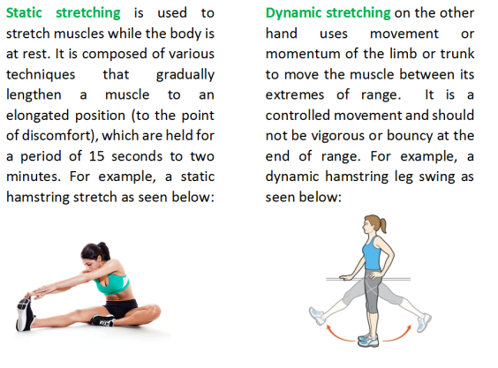
**NEVER STRETCH YOUR MUSCLES BEFORE YOU WARM YOUR BODY UP! It can actually DECREASE your performance ability and cause INJURY! A great time to stretch would be after your given Warm-Up routine or during the conclusion of your workout and/or Cool-Down.

FITNESS PLAN CALENDAR
Use the calendar template to map out your upcoming fitness routine for the next two months. Make sure you create this workout routine with a REALISTIC approach. Give yourself adequate rest days on actual days you feel would best meet your schedule. Plan the routine toward your fitness goals and focus them around the FITT Principle recommendations to make sure you are not overworking yourself, while still pushing yourself to the fullest potential.

When completing the given calendar templates, make sure you are as DETAILED as possible. Always include the exact Warm-up, Stretches, Exercise Routine, and Cool-Down that you plan to do. It will help you visualize your weeks ahead and assure that you are meeting both your Fitness Goals and the FITT Principle. For “OFF DAYS”, draw an X over them rather than leaving them blank to give yourself a better visual. With this in mind, you are ensuring yourself the most likelihood of a positive outcome.

To make it easier, you can list the given elements in abbreviated form:
Warm-up: WU Dynamic Stretch: DS
Static Stretch: SS Work Out/Activity: WO
Cool Down: CD

Hang the Calendars and Fitness Goals next to one another to continually remind yourself what you’re working toward!

After completing the two months of activities listed throughout your calendars and tracking your fitness progress, you should re-assess your fitness goals, create new ones, if applicable, and create new calendars to follow. This can be done every two months to continue improving and maintaining your fitness.

Don’t expect a quick fix; health and fitness come with hard work and dedication, but the results are WORTH IT and YOU ARE WORTH IT. What you do today will affect how you feel tomorrow….Make your tomorrows better and aim to live a more active and healthy lifestyle!
WEEK 5 WEEK 4 WEEK 3 WEEK 2 WEEK 1
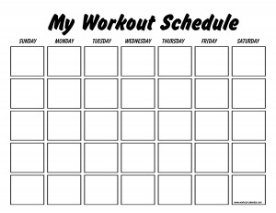

NOTES:

WEEK 10 WEEK 9 WEEK 8 WEEK 7 WEEK 6

NOTES:

Sources:
http://hawkspe.weebly.com/fitt-principle-of-exercise.html

http://www.ode.state.or.us/teachlearn/subjects/pe/curriculum/fittprinciple.pd

http://www.heart.org/HEARTORG/HealthyLiving/PhysicalActivity/FitnessBasics/Warm-Up-Cool-Down_UCM_430168_Article.jsp#.V-kuJ4grKJA

http://www.randall.k12.wi.us/cms/lib01/WI01001877/Centricity/Domain/52/Fitness%20Focus.pdf

http://www.heart.org/HEARTORG/HealthyLiving/PhysicalActivity/FitnessBasics/Target-Heart-Rates_UCM_434341_Article.jsp#.Vw0qwdQrKJA

http://www.topendsports.com/testing/tests/sit-and-reach.htm

https://www.adultfitnesstest.org/testInstructions/muscularStrengthAndEndurance/pushups.php

http://thefitnessfocus.com/fitness-tips/body-measurement-tracking-chart

https://ychikingclass.wordpress.com/cardiovascular-fitness/

http://www.tigerwires.com/Page/593

http://www.lifespanfitness.com/fitness/resources/target-heart-rate-calculator

https://stadiumsportsphysio.wordpress.com/tag/static-stretching/

http://www.mrsicklerphysicaleducation.com/AddResources/2_Week_Fitness_Plan_files/FitnessPlanFullPacketv2.1.doc

